**Exercise 2 – The Hui-Walter model**

In this session we will apply a Bayesian Latent class model to the data/observations from the manuscript published back in 1980 (Table 1).

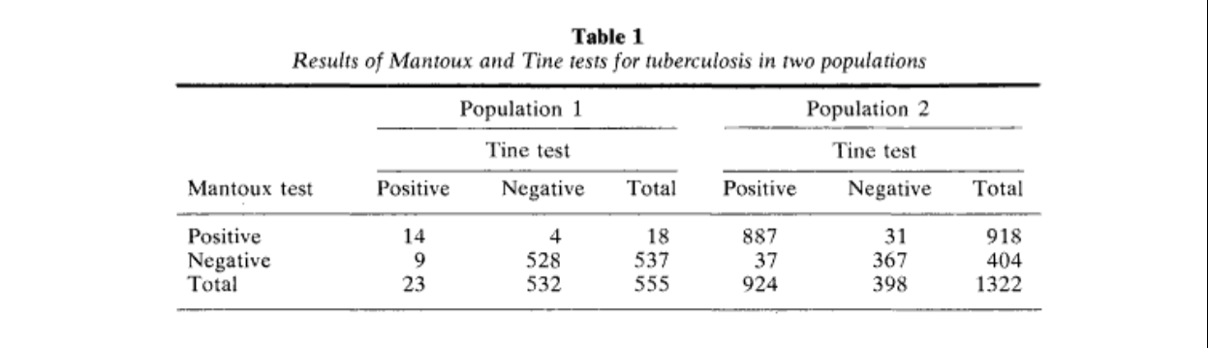

Estimating the Error Rates of Diagnostic Tests, S. L. Hui and S. D. Walter, 1980

1. Add population 1 of table 1 in your working directory, with the following lines of code.

pop_1 = matrix(nrow=3,ncol=3)

rownames(pop_1) = c("Mantoux_Test_Pos", "Mantoux_Test_Neg", "Total")

colnames(pop_1) = c("Tine_Test_Pos", "Tine_Test_Neg", "Total")

pop_1[1,1] = 14

pop_1[1,2] = 4

pop_1[2,1] = 9

pop_1[2,2] = 528

#Total rows and columns

pop_1[1,3] = pop_1[1,1] + pop_1[1,2]

pop_1[2,3] = pop_1[2,1] + pop_1[2,2]

pop_1[3,1] = pop_1[1,1] + pop_1[2,1]

pop_1[3,2] = pop_1[1,2] + pop_1[2,2]

N_1 = sum(pop_1[1,1] + pop_1[1,2] + pop_1[2,1] + pop_1[2,2])

pop_1[3,3] = N_1

pop_1

1. Do the same with pop_2

pop_2 = matrix(nrow=3,ncol=3)

rownames(pop_2) = c("Mantoux_Test_Pos", "Mantoux_Test_Neg", "Total")

colnames(pop_2) = c("Tine_Test_Pos", "Tine_Test_Neg", "Total")

pop_2[1,1] = 887

pop_2[1,2] = 31

pop_2[2,1] = 37

pop_2[2,2] = 367

#Total rows and columns

pop_2[1,3] = pop_2[1,1] + pop_2[1,2]

pop_2[2,3] = pop_2[2,1] + pop_2[2,2]

pop_2[3,1] = pop_2[1,1] + pop_2[2,1]

pop_2[3,2] = pop_2[1,2] + pop_2[2,2]

N_2 = sum(pop_2[1,1] + pop_2[1,2] + pop_2[2,1] + pop_2[2,2])

pop_2[3,3] = N_2

pop_2

1. Write the 2_test_2_population model and save as “hw_blca.bug”.

model{

Population_1 ~ dmulti(prob_1, N_1)

#Population_1

# Test1+ Test2+

prob_1[1] <- (prev[1] * ((se[1])*(se[2]))) + ((1-prev[1]) * ((1-sp[1])*(1-sp[2])))

# Test1+ Test2-

prob_1[2] <- (prev[1] * ((se[1])*(1-se[2]))) + ((1-prev[1]) * ((1-sp[1])*(sp[2])))

# Test1- Test2+

prob_1[3] <- (prev[1] * ((1-se[1])*(se[2]))) + ((1-prev[1]) * ((sp[1])*(1-sp[2])))

# Test1- Test2-

prob_1[4] <- (prev[1] * ((1-se[1])*(1-se[2]))) + ((1-prev[1]) * ((sp[1])*(sp[2])))

#Population_2

Population_2 ~ dmulti(prob_2, N_2)

# Test1+ Test2+

prob_2[1] <- (prev[2] * ((se[1])*(se[2]))) + ((1-prev[2]) * ((1-sp[1])*(1-sp[2])))

# Test1+ Test2-

prob_2[2] <- (prev[2] * ((se[1])*(1-se[2]))) + ((1-prev[2]) * ((1-sp[1])*(sp[2])))

# Test1- Test2+

prob_2[3] <- (prev[2] * ((1-se[1])*(se[2]))) + ((1-prev[2]) * ((sp[1])*(1-sp[2])))

# Test1- Test2-

prob_2[4] <- (prev[2] * ((1-se[1])*(1-se[2]))) + ((1-prev[2]) * ((sp[1])*(sp[2])))

prev[1] ~ dbeta(1, 1)

prev[2] ~ dbeta(1, 1)

se[1] ~ dbeta(1, 1)T(1-sp[1], )

sp[1] ~ dbeta(1, 1)

se[2] ~ dbeta(1, 1)T(1-sp[2], )

sp[2] ~ dbeta(1, 1)

#data# Population_1, Population_2, N_1, N_2

#monitor# prev, prob_1, prob_2, se, sp

#inits# prev, se, sp

}

1. Attach the “runjags” package

library(runjags)

1. Specify the data in R environment

Population_1 <- as.numeric(pop_1[1:2,1:2])

Population_2 <- as.numeric(pop_2[1:2,1:2])

1. Define the initial values data for the MCMC chains:

prev <- list(chain1=c(0.05,0.99), chain2=c(0.95,0.05))

se <- list(chain1=c(0.5,0.99), chain2=c(0.99,0.5))

sp <- list(chain1=c(0.5,0.99), chain2=c(0.99,0.5))

1. Run the model

results <- run.jags(“hw_blca.bug”, n.chains=2, burnin=5000, sample=10000)

1. Plot and view the results

summary(results)

pt <- plot(results)

pt$`prev[1].plot1`

pt$`prev[1].plot3`

print(pt[["prev[1].plot1"]])

print(pt[["se[1].plot1"]])

print(pt[["sp[1].plot1"]])

print(pt[["sp[1].plot3"]])